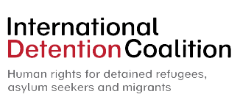

FRIENDS WORLD COMMITTEE FOR
CONSULTATION (QUAKERS)
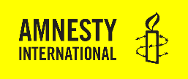

HRC 34th session
10th March 2017
Item 3: Enhanced Interactive Dialogue on the human rights of migrants

By Amnesty International, Belgrade Centre for Human Rights, International Detention Coalition, International Service for Human Rights, Save the Children, Terre des Hommes International and Friends World Committee for Consultation (Quakers).

Mr President,
This statement is delivered on behalf of Save the Children and six NGOs.
With xenophobic populism on the rise across the globe, posing threat to universal values, this statement is an appeal to the international community to uphold and defend human rights standards and the inherent dignity of all human beings. We currently face an unprecedented protection and humanitarian crisis, where migrants’ lives hang in the balance and increasingly restrictive state policies become the norm. We call on the Human Rights Council to show leadership in addressing human rights violations against migrants and standing up for the human rights of marginalized groups and those who provide assistance to them.
The next 18 months will see the development of two Global Compacts, on safe, orderly and regular migration and on refugees. The Office of the High Commissioner for Human Rights, the Human Rights Council, Special Procedures and Human Rights Treaty Bodies have a vital role to play in ensuring that the Compact on Migration is human rights-based, and consistent with existing international human rights standards. It should also provide a space for migrants, including migrant children, to be at the forefront of these discussions to inform the development of the Compact.
Ultimately a key test of success of the Compact is how it will respond to the needs and ensure the protection of all migrants in vulnerable situations. Migrant children, in particular, have specific protection needs and face higher risks of abuse, violence and exploitation along the migration route and in destination countries. Often they are not afforded adequate protection and support, and face discrimination, suspicion and detention.
We welcome the Global Migration Group draft principles and guidelines on the human rights protection of migrants in vulnerable situations as a tool which will help translate human rights principles into practical measures. We hope that they will serve as a useful contribution to the Global Compact.

Mr President,
Children’s rights are not optional and cannot be taken away from children when they cross borders, irrespective of whether their migration is regular. Children on the move are children first and foremost, subject of rights independent of their migration status. This principle should underlie the two Global Compacts.
A broad coalition of organisations, including UN agencies and NGOs have come together to promote child rights in the Global Compacts and develop harmonized child focused goals, targets and indicators. We encourage member states and other stakeholders to join us and support this initiative to champion the rights and needs of migrant children and make them a reality.
Thank you.

